**Rundeck configuration in Local machine**

**(192.168.33.11)**

**Installation process:**

yum install java-1.8.0   
rpm -Uvh<http://repo.rundeck.org/latest.rpm>   
yum install rundeck   
service rundeckd start

* Go to below location and add the ip address of your server.
* Suppose my server ip is 192.168.33.11

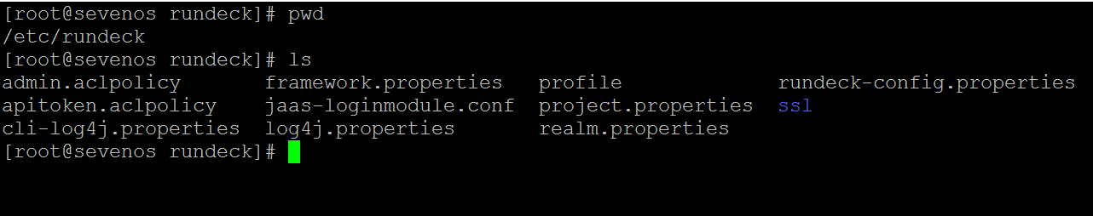

* And select the rundeck-config.properties
* Vi rundeck-config.properties

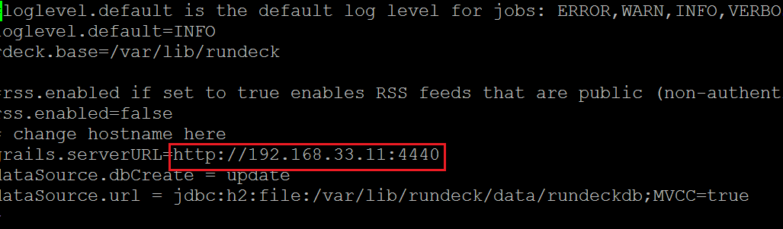

* Then run the command **reboot**

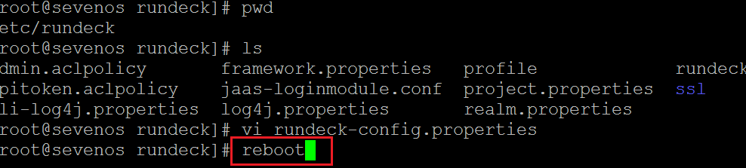

* Open browser and run the ip**192.168.33.11:4440**
* **Username : admin**
* **Password: admin**
* Then click on the new project and follow the below screenshots.
* 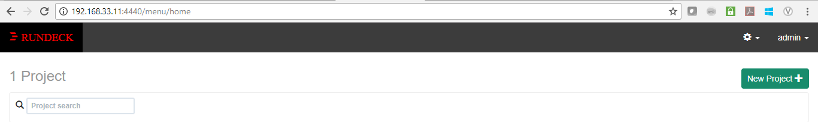
* 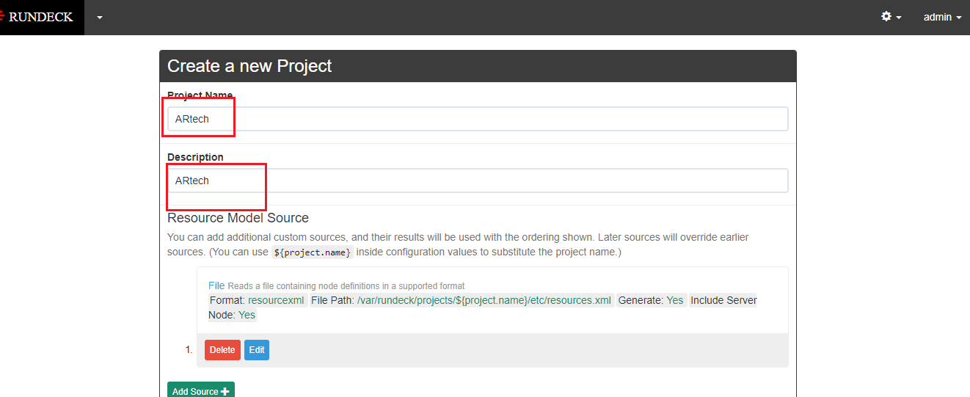
* 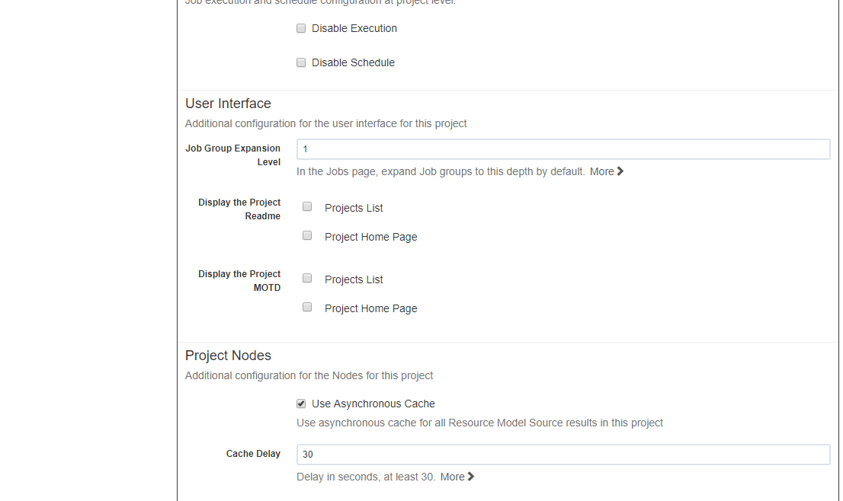
* 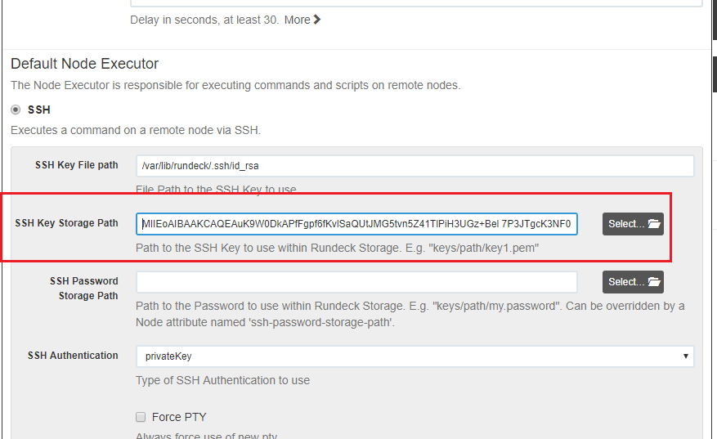
* FOR SSH key storage path you have to go below paths**.**
* 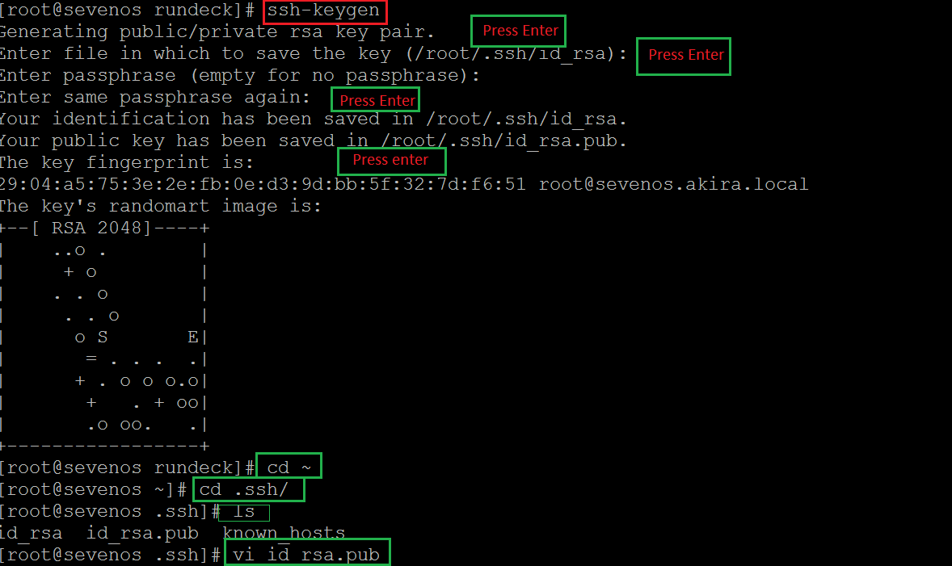
* 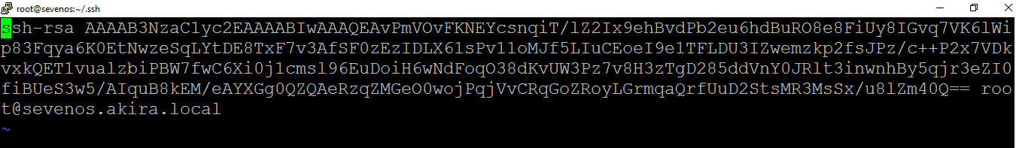
* **Copy that code and paste in rundeck.**
* 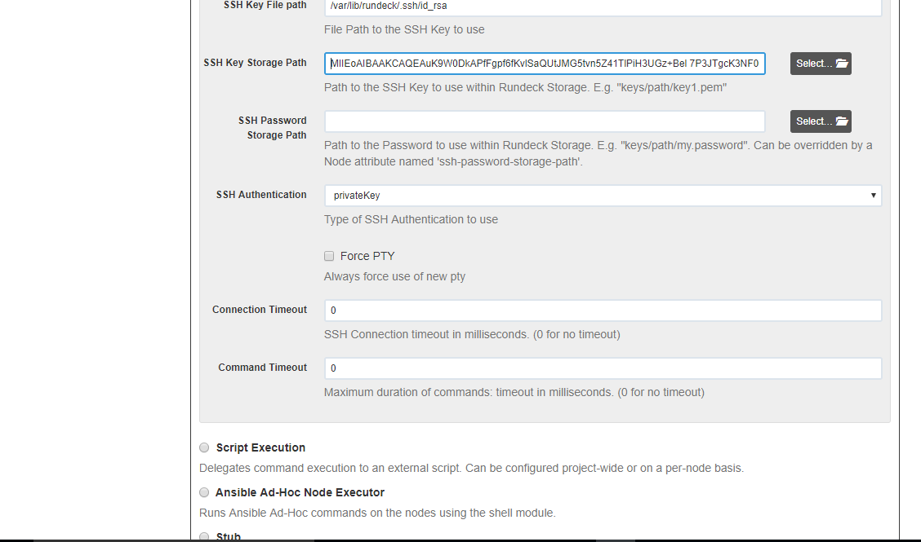
* 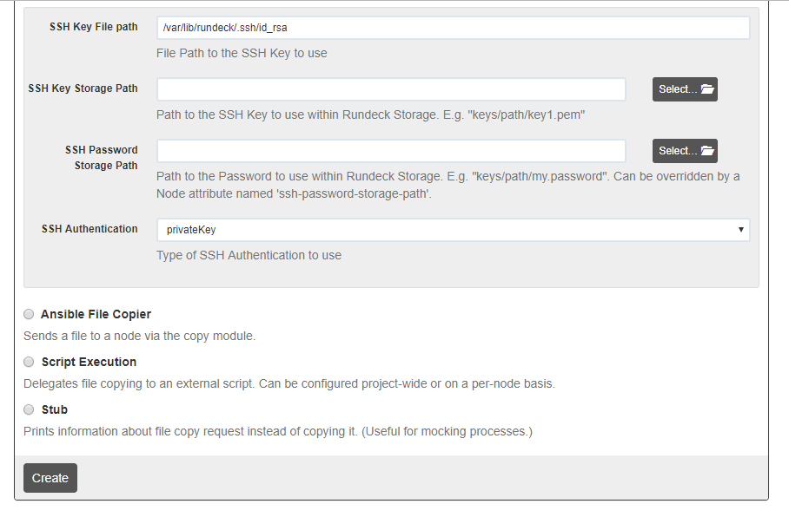
* **You have to click on create.**
* **Then below screen you will get.**
* 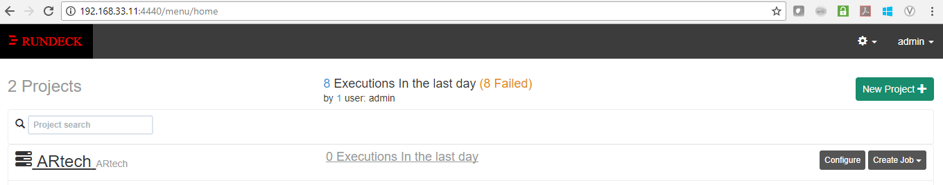
* **Click on your ARtech job and follow below screenshots.**
* 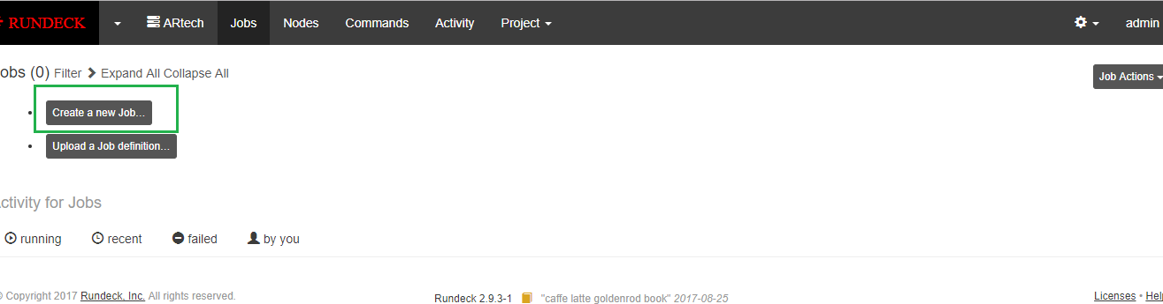
* 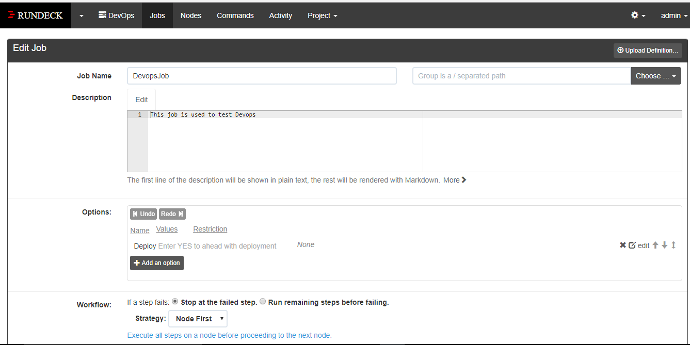
* 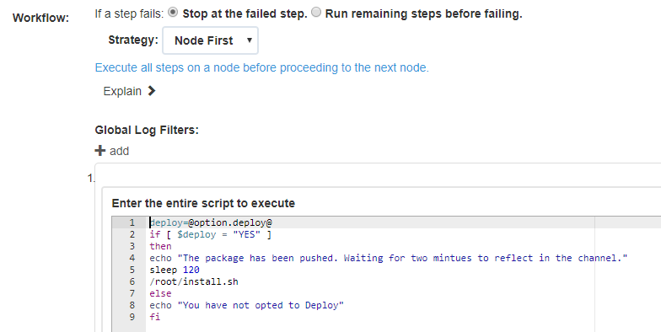
* 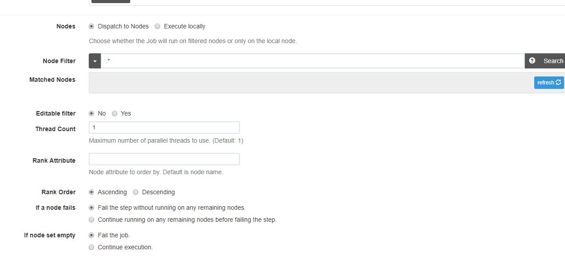
* 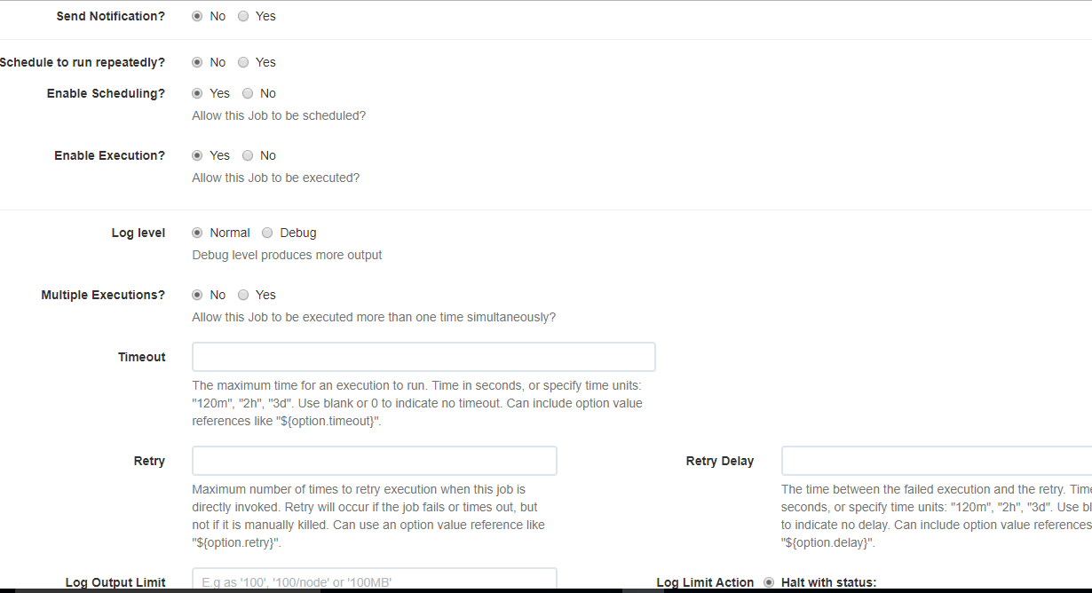
* 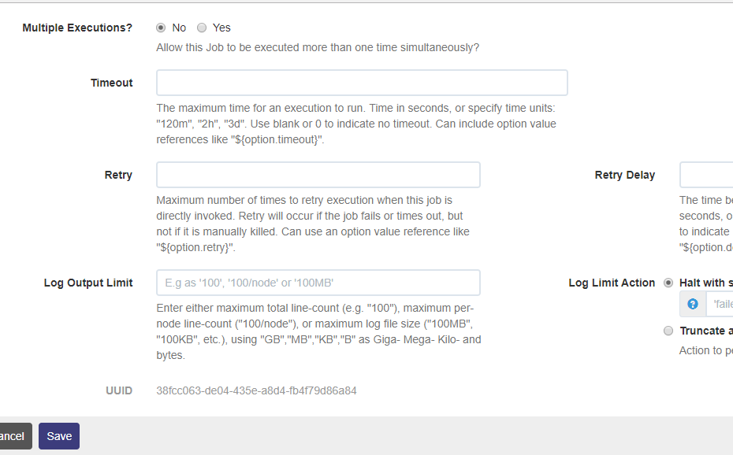
* **Then finally click on save below screen you will get.**
* 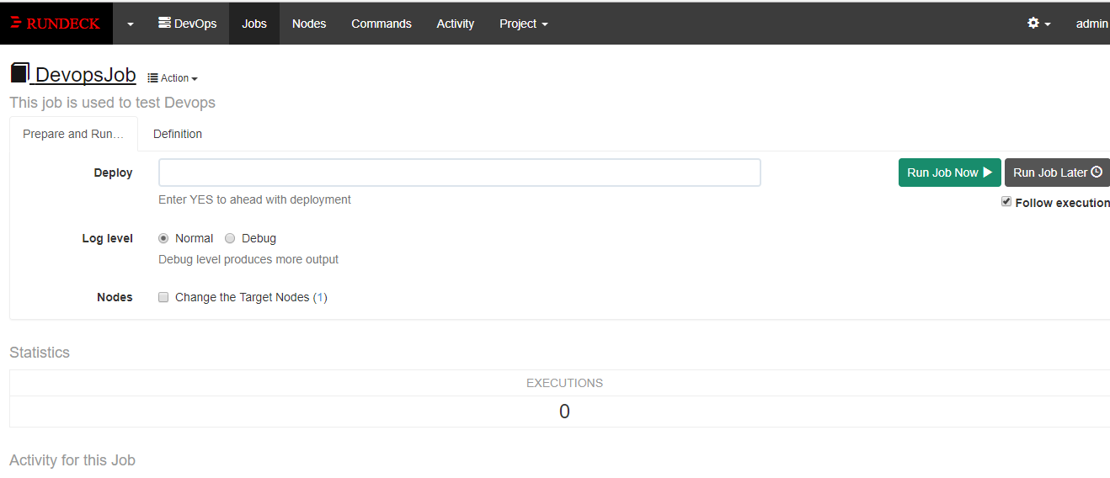
* **Then click on Definition.**
* 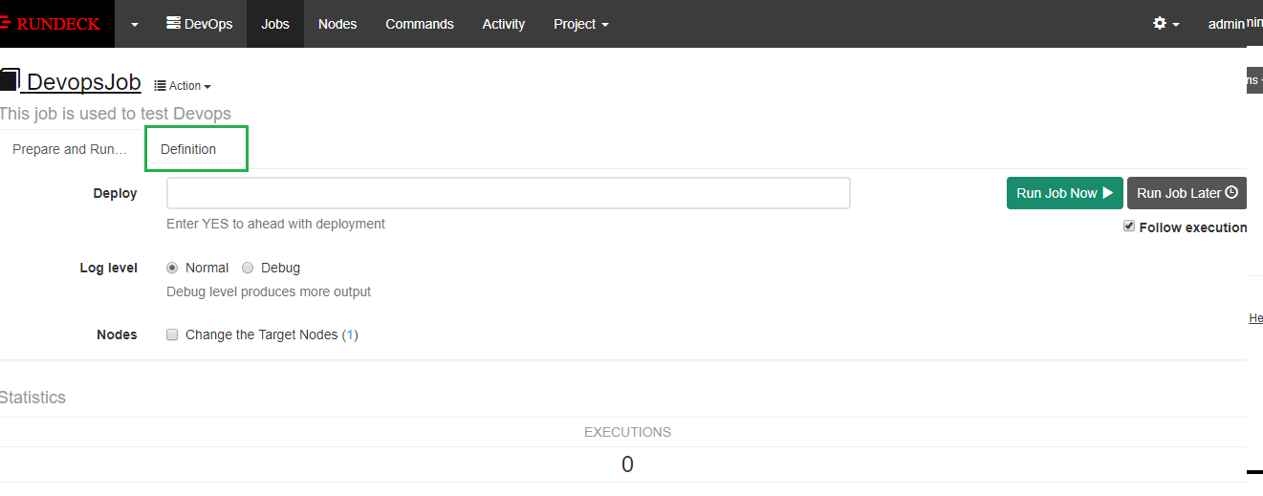
* 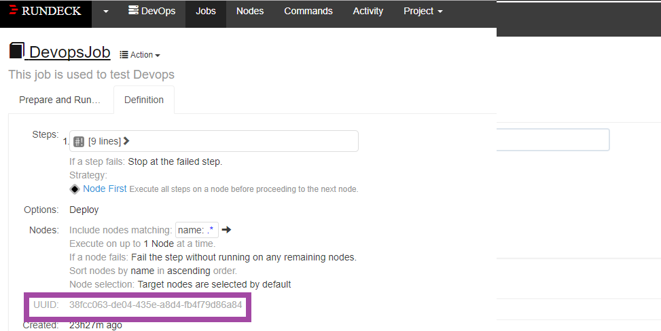
* **Finally you got UUID code take that code and configure in Jenkins job.**
* 

